**Project 2 Report**

**Colter Roche**

**4/14/19**

**Introduction:**

The goal of the project was to build a program that would take input from the user and generate a random maze, then solve it using backtracking. The final version of the program is able to do this successfully. The path taken is marked out with “@” symbols, and while the path is not the most efficient route, it does not cross. The program was compiled and tested on Windows 10 version 18875, using MingW32 and g++. The source code should be compatible across platforms, but no others have been tested. There is still some instability with solving the maze, but most tests have been successful.

**Results:**

The program is able to completely solve the maze within a few seconds to several minutes, depending on the size and complexity of the maze. Three test runs are shown below.

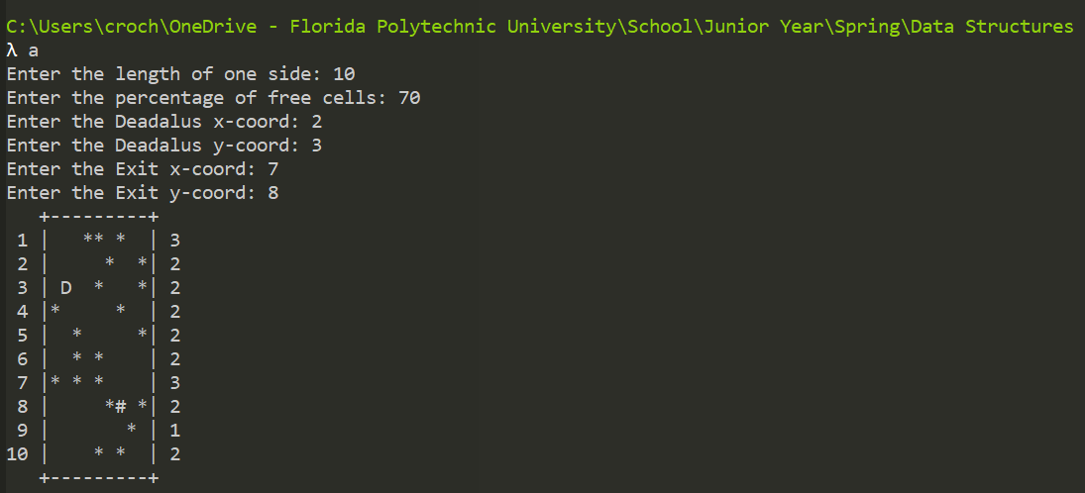

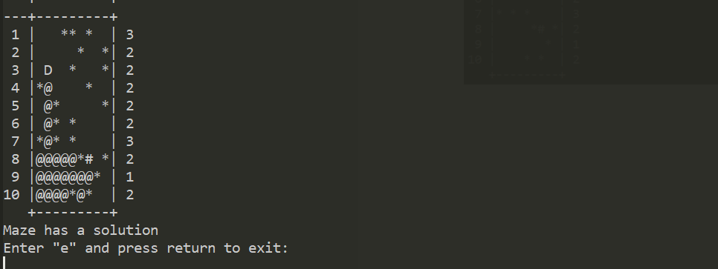

There are issues on larger mazes with the end or start points getting removed during solving.